AMERICAN CAR CRAFT
18701 Old Shady Hill Rd. Spring Hill, Fl. 34610
Phone: 727 857-1151 Fax: 727 856-0273
www.americancarcraft.com

HHR STAINLESS REAR BUMPER INSERT
INSTALLATION INSTRUCTIONS
PART # HHBI211

PARTS INCLUDED:
___1-Stainless Brushed Bumper Insert
___1-Adhesive Promoter Packet
___1-Adhesive Promoter Tube
___2-Lengths of Chrome Trim

This accessory comes to you with a clear protective liner. Do not remove this liner until installation is complete.

1. Thoroughly clean the area to be mounted with rubbing alcohol to remove any and all dirt and wax. Then swipe the area with the adhesive promoter packet provided.

2. Place the unit so that it lines up with the two back up light opening to get acquainted with just how you will set it in place and also to check the overall fit. Once you are satisfied with the fit simply peel the red release liner from the two strips on the back of the insert then carefully set in place. Press firmly to set.

3. You have been provided with two different sizes of chrome trim of the same length.
Apply a narrow bead of adhesive promoter tube directly to the paint above and below the insert. Use the smaller trim for the top and the larger for the bottom. To install the two trim lengths simply peel the red releaser liner from the back of each length and set in place directly to the paint and nice and tight against the insert. Press firmly along the lengths to set. Remove the protective liner.

DO NOT GET WET FOR 24 HOURS!
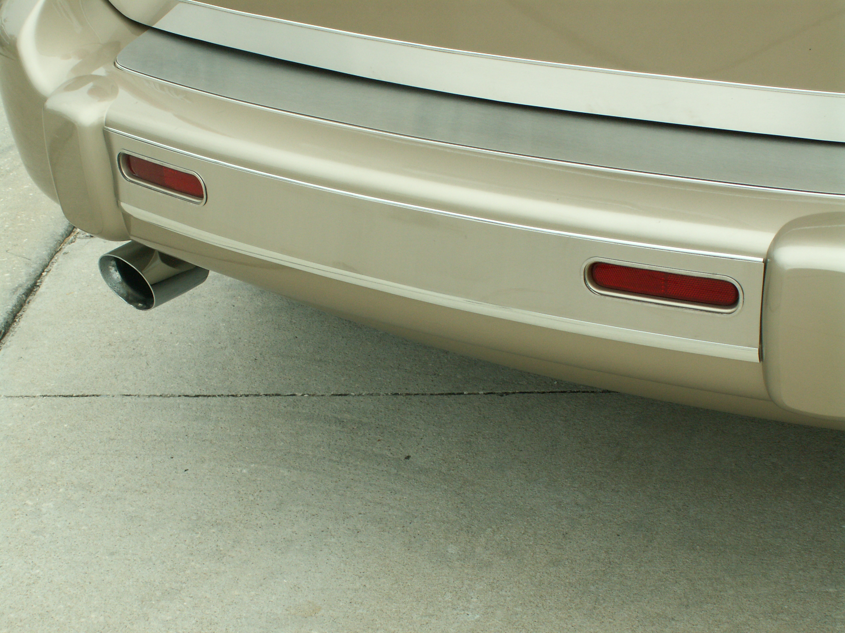

If any questions occur during installation please contact American Car Craft @ 727 857-1151

Thank you and enjoy your purchase!

Note: EXTRA CARE must be taken when cleaning your stainless trim. It is a good idea to lightly dust your trim with a clean soft cloth first in order to prevent any particles from scratching it. Then wipe (using a new clean soft cloth) with a good quality streak free glass cleaner.

